Upload videos to FreeKnowledgeMission YouTube Account

1. Accept manager invitation by email
2. Visit [www.youtuble.com](http://www.youtuble.com)
   1. Click you profile in the top right screen
   2. Click switch account

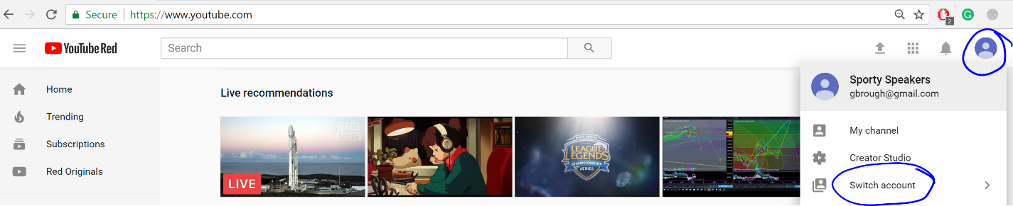

1. Click FreeKnowledgeMission



1. Click upload in the top right

